**Software Requirements Specification**

**PRJ566 – Fall 2024**

**PRJ566 – Team No: 7**

**Name of Project:  AI Integrated Grocery List Application**

Project Leader: **Jeevanjot Khehra**

**Last updated: October 6, 2024**

**Team Members:**

**1. Arashdeep Singh**

**2. Jeevanjot Khehra**

**3.**  **Mustafa Toygar Baykal**

**4. Vedant Sharma**

## 2.5 Project Scope

### **Within Scope:**

1. **User Account Management:**

* User registration and authentication
* Personalized profile creation
* Privacy settings

1. **Grocery List Generation**

* Manual list creation by user
* Grocery needs prediction based on users’ past purchases

1. **Dietary and Preference Settings**

* User-decided dietary preferences (e.g., vegan, gluten-free)
* Allergy information management

1. **Budget Management**

* Personalized budget limiting
* Budget alerts based on the pre-set limit

1. **Mobile Application Development**

* IOS and Android app development
* UI design and implementations
* Offline functionality for basic features

### **Out of Scope:**

1. **Physical Grocery Delivery Services**
2. **IoT Integration with Smart Home Devices**
3. **In-pp Payment System for Groceries**
4. **Developing of Grocery Store Management System**

## 2.6 System Risks

|  |  |
| --- | --- |
| Risk | Response |
| Not all members are familiar with Android development | Hold team sessions to go over the Android Studio and how to initialize an APK for app testing / |
| Market Competition | Continuously innovate and add unique features. Focus on building a strong brand and user community. Monitor competitor activities and adapt strategies accordingly. |
| User Adoption Resistance | Develop a user-friendly UI/UX. Offer incentives for early adopters. Gather and respond to user feedback regularly. |
| Dependency on Third-party Services | Carefully vet and select reliable third-party providers. Develop contingency plans for service disruptions. Consider developing critical functionalities in-house where feasible. |
| Not all members are familiar with Android development | Hold team sessions to go over the Xcode. |

## 2.7 Operating Environment

### **Hardware Environment:**

* Mobile devices (smartphones and tablets) running iOS and Android operating systems.
* Cloud servers to host the application and handle data processing.

## **Software Environment:**

* Cross-platform mobile application development framework (e.g., React Native or Flutter) for iOS and Android compatibility.
* Cloud-based infrastructure (e.g., AWS, Google Cloud, or Azure) for backend services.
* Database management system (e.g., PostgreSQL or MongoDB) for storing user data and product information.

### **Security Environment:**

* End-to-end encryption for all data transmissions (HTTPS with TLS).
* Secure user authentication system.

### **Compliance Environment:**

* Adherence to basic data protection regulations.
* Compliance with local regulations regarding AI and automated decision-making systems.
* Compliance with data protection laws for customer privacy.

## 2.8 UI/UXD Interface Mock-ups

**Login Interface:** 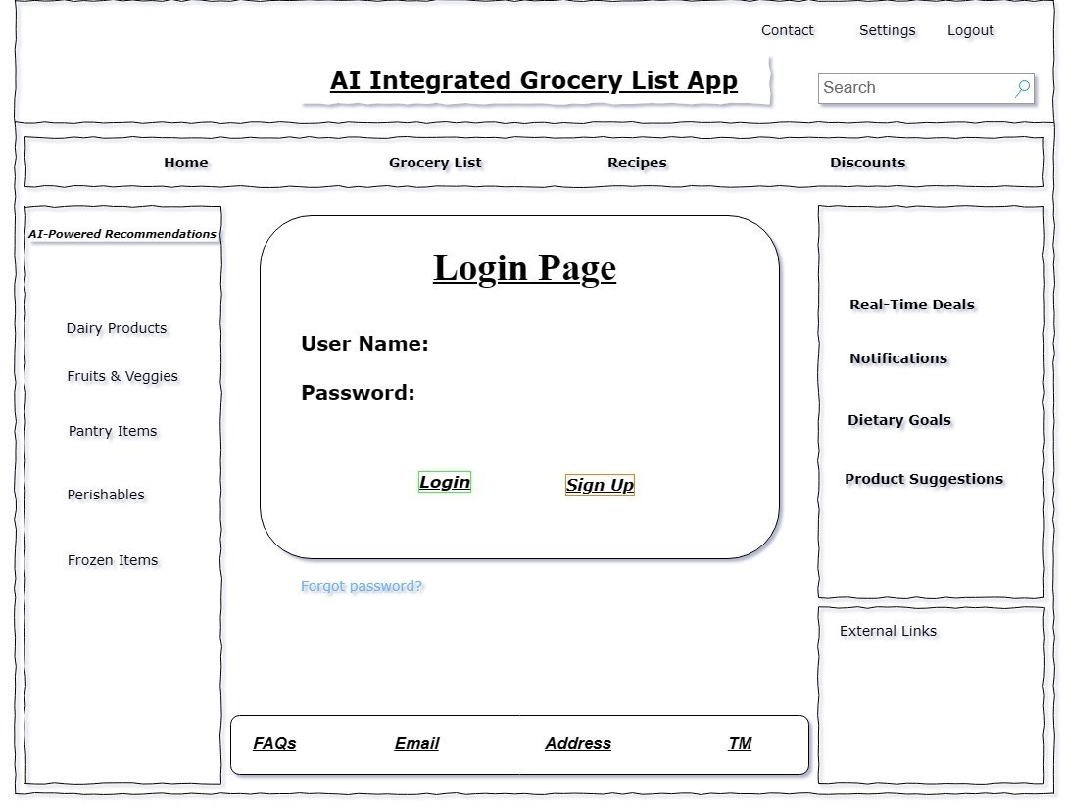

**Shopping List Interface:**   
